

Automatic Trading Software
Warning this is a beta version and only for demo accounts.
Beta version 1.1

USER’S MANUAL

Manual
Scalper systems Ltd. © 2001, 2002, 2003, 2004, 2005,2006

LEGAL NOTICE
BY USING THIS SOFTWARE, USER ASSUMES ALL RISKS AND AGREES TO HOLD DEVELOPER HARMLESS FROM ALL ACTIONS ARISING FROM THE USE OR RELIANCE UPON THIS SOFTWARE.

Unless otherwise stated, this program and all related documentation is Copyright 2006 All Rights Reserved.

Microsoft, Windows, Windows 95, Windows98, Windows2000, Windows NT, Excel and Visual Basic are registered trademarks of Microsoft Corporation. Omega Research, TradeStation, SuperCharts, ProSuite, Easy Language, ShowMe, PaintBar are registered trademarks of Tradestation .

Scalper Set Up

- Run SetupScalper TC.msi (TradeStation should be closed during installation).
- Import TradeStation strategy _Scalper (_Scalper .ELD file located in …\Scalper\Export directory, also shortcut to this file is placed on the Desktop during the installation).
- Insert _Scalper strategy on TradeStation Chart Analysis Window (this strategy should be the last one among the all strategies applied to the chart)
- Run Scalper TC (shortcut to the program is located on the Desktop)
- Click Mapping Table link on the Scalper TC main screen.
Define mapping attributes: TSSymbol (TradeStation symbol), TSExchange (TradeStation Exchange), TradeExchange (Ffastfill Exchange), TradeSymbol (Currenex ), MonthYear, TradeSize (Default Number of Contracts/Shares traded trade size ).
- Check Use Symbol Mapping checkbox.
- Check Use Default Trade Size checkbox if default trade size should be used.
- Click Connect button to connect to Currenex.

Important!!!
To be able to capture trade alerts from TradeStation Scalper TC application should be running.
Scalper TC translates trade alerts (Filled Orders from the TradeStation) into Currenex Market Orders for execution only after/if connection to the Currenex is successfully established.

For help logging onto to call Support -- 0044-02071830500
To Contact me for technical support the no to ring me on is 0044-1535-669338

Log in

- Log in details are as below in password you need to enter password you obtain either from me direct of from your broker in lowercase and insert in sender all the rest of the details remain the same .

- 0n the interface press connect once connected there is a red light on the interface will go green...then you are all set ..to go ..
Important:
Log in details as below click on file then settings

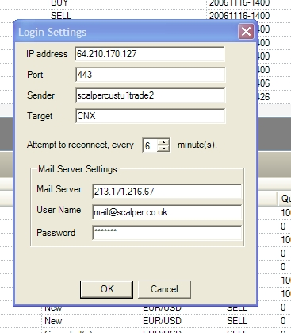

- Check boxes below for no execution manual confirmation and automated were all orders will be sent direct with out confirmation .
- We suggest that you set it to manual to check orders are correct before sending

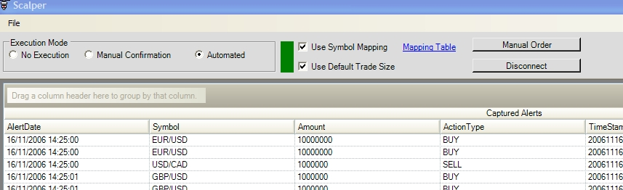

Mapping table:
- Click Mapping Table link on the Scalper TC main screen.
Define mapping attributes: TSSymbol (TradeStation symbol), TSExchange (TradeStation Exchange), TradeExchange (Currenex Exchange), TradeSymbol (Currenex ), MonthYear, TradeSize (Default Number of Contracts/Shares traded trade size ).

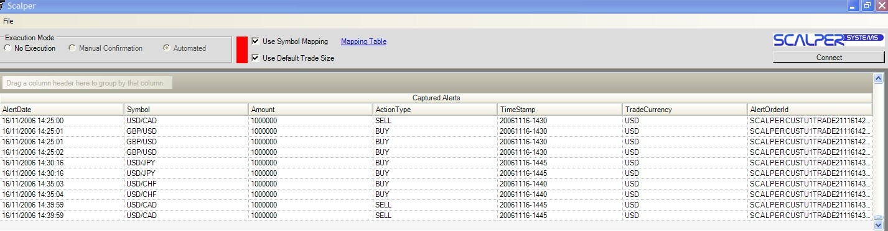

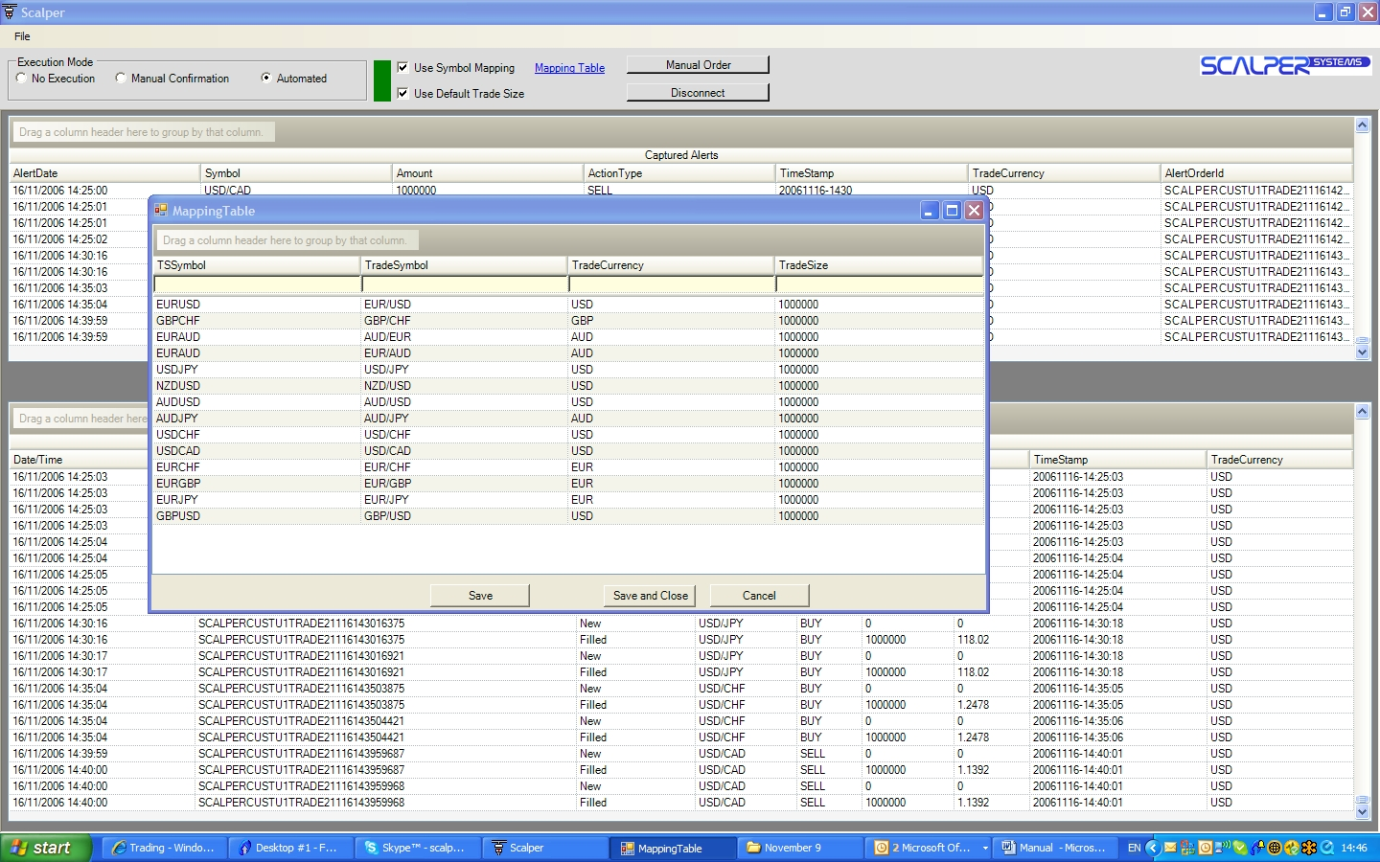

In mapping table symbols are already set for the majors and minors should you wish change them then refer to mapping table in this document . Trade size set to 100,000

Should you need assistance we can log onto your machine direct to configure the application please email us at sales@scalper.co.uk or telephone us 0044-1535-669338.

Technical support
Contact Franco Dimuccio
0044-1535-669338
Scalper Systems
14 Victoria Mews
Keighley .W.York
BD212SF
Email@sales@scalper.co.uk

Good luck
Franco Dimuccio
www.scalper.co.uk

